**CSE2003 – Data Structure and Algorithms**

**J Component Report**

**A project report titled Hands on English**

**J Title**

*By*

Reg. No - 19BCE1672 Name - Sarthak Keshari

Reg. No - 19BCE1093 Name - Gazal Madan

Reg. No - 19BCE1528 Name - Aditya Mishra

BACHELOR OF TECHNOLOGY

IN

COMPUTER SCIENCE AND ENGENEERING

*Submitted to*

**Dr. R. Rajalakshmi**

**School of Computer Science and Engineering**



*November 2020*

*­­­*

**DECLARATION BY THE CANDIDATE**

I hereby declare that the report titled “**Hand On English”** submitted by me to VIT Chennai is a record of bona-fide work undertaken by me under the supervision of **Dr. R. Rajalakshmi, Associate Professor, SCOPE, Vellore Institute of Technology, Chennai.**



Signature of the Candidate

**ACKNOWLEDGEMENT**

We wish to express our sincere thanks and deep sense of gratitude to our project guide, **Dr. R. Rajalakshmi,** School of Computer Science and Engineering for her consistent encouragement and valuable guidance offered to us throughout the course of the project work.

We are extremely grateful to **Dr. R. Jagadeesh Kannan, Dean,** School of Computer Science and Engineering (SCOPE), Vellore Institute of Technology, Chennai, for extending the facilities of the School towards our project and for his unstinting support.

We express our thanks to our **Head of the Department** for his support throughout the course of this project.

We also take this opportunity to thank all the faculty of the School for their support and their wisdom imparted to us throughout the courses.

We thank our parents, family, and friends for bearing with us throughout the course of our project and for the opportunity they provided us in undergoing this course in such a prestigious institution.

**BONAFIDE CERTIFICATE**

Certified that this project report entitled “**Hands On English”** is a bona-fide work of **Sarthak Keshari (19BCE1672), Gazal Madan (19BCE1093), Aditya Mishra (19BCE1528)** carried out the “J”-Project work under my supervision and guidance for CSE2003 – Data Structure and Algorithm.

**Dr. R. Rajalakshmi**

SCOPE

**TABLE OF CONTENTS**

|  |  |  |
| --- | --- | --- |
| **Ch. No** | **Chapter** | **Page Number** |
| 1 | Introduction | 7 |
| 2 | Literature Survey / Requirements | 8 |
| 3 | Proposed System / Module(s) description | 9 |
| 4 | Results and Discussion | 20 |
| 5 | Conclusion | 22 |
| 6 | Reference | 23 |
| 7 | Appendix | 24 |

**ABSTRACT**

This is a multitasking website that contains numerous features like grammar and vocabulary tests, searching words in a dictionary and much more. The use of multiple data structures in building this website made it more efficient for the students to use, various events are arranged for students to take part, lectures are also delivered which is useful for the current and the future generation as well.

We will design the functionality of this website by comparing with other well-established websites and making it a combination of all the best features which further makes it a very precise and extraordinary website.

There is much more exciting you will find in this website that will drive you to the other world of technology and smartness.

**INTRODUCTION**

English as an international language, it is a demand of today’s world. For surviving in society, people have to understand and speak the English language fluently.

In this world, you go everywhere the people can speak or even understand the English language. It plays a greater role for the people in a society.

The English language is an important subject for the people whose English is not their native language. For surviving in society, they have to learn, understand and speak English fluently.

For communicating and sharing thoughts with the people belong to other regions who speak different languages, the English language is a common language to communicate with them.

The students who want to go to the foreign country for studying purpose have to understand and speak the English language for the sack of surviving in foreign countries.

“Hands On English” provides solution to all the above-mentioned problems. It will not just improve the knowledge of new words but also improves one’s vocabulary by providing the facility to attend quizzes, scoring marks and competing with other students throughout the world.

On this platform we can also view the rank that is calculated on the basis of marks of all the students who have attended the same quiz. This will further keep the user updated about his/her performances which can help them to improve their performance and can learn in a better way.

We as a team, aim to focus more on “Learning” rather than “Earning”.

**LITERATURE SURVEY / REQUIREMENTS**

English is widely spoken language so make an easy and handy way to grasp grammar and vocab we formulated the plan for this website.

So, we are trying to help people by making this magnificent site which include various techniques by which one can improve his language.

Knowing English increases your chances of getting a good job in a multinational company within your home country or for finding work abroad.

We surveyed multiple platforms and brought out a plan to inculcate all the features at one place making the experience user-friendly.

**PROPOSED SYSTEM / MODULE(S) DESCRIPTION**

* **DICTIONARY**

Under this, students can search the meaning of a particular word that they want to know which will further help them improving their vocabulary.

For implementation we used Multiple Child Tree, so that students can search for words and their respective meanings.

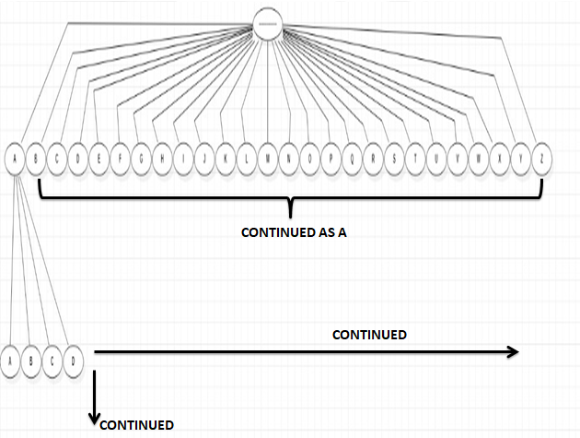

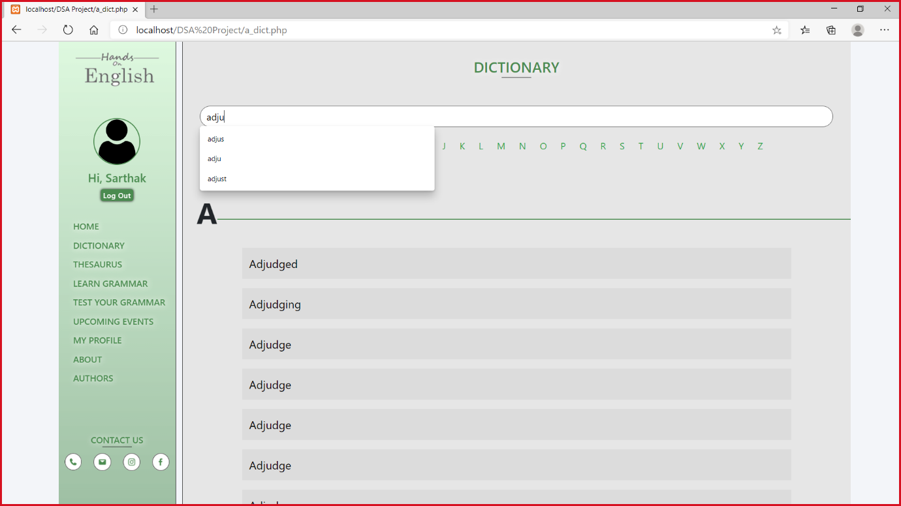

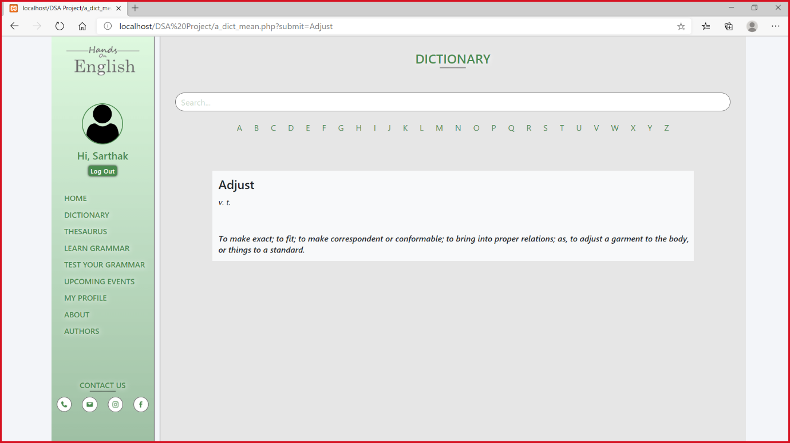

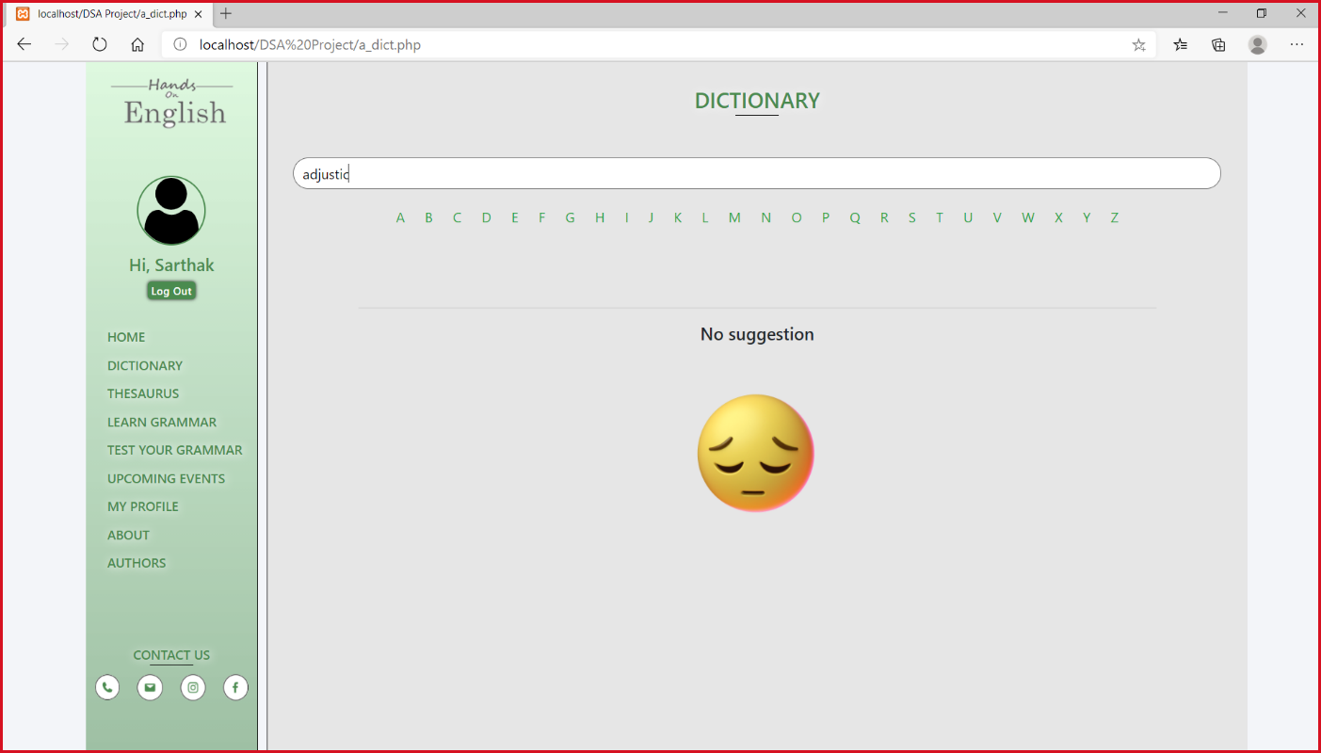

* **THESAURUS**

Under this, students can find the antonyms, synonyms and also the use of the particular word in different sentences.

We used General Tree for Thesaurus too so that we can search antonyms, synonyms and the usage of particular word in sentences.

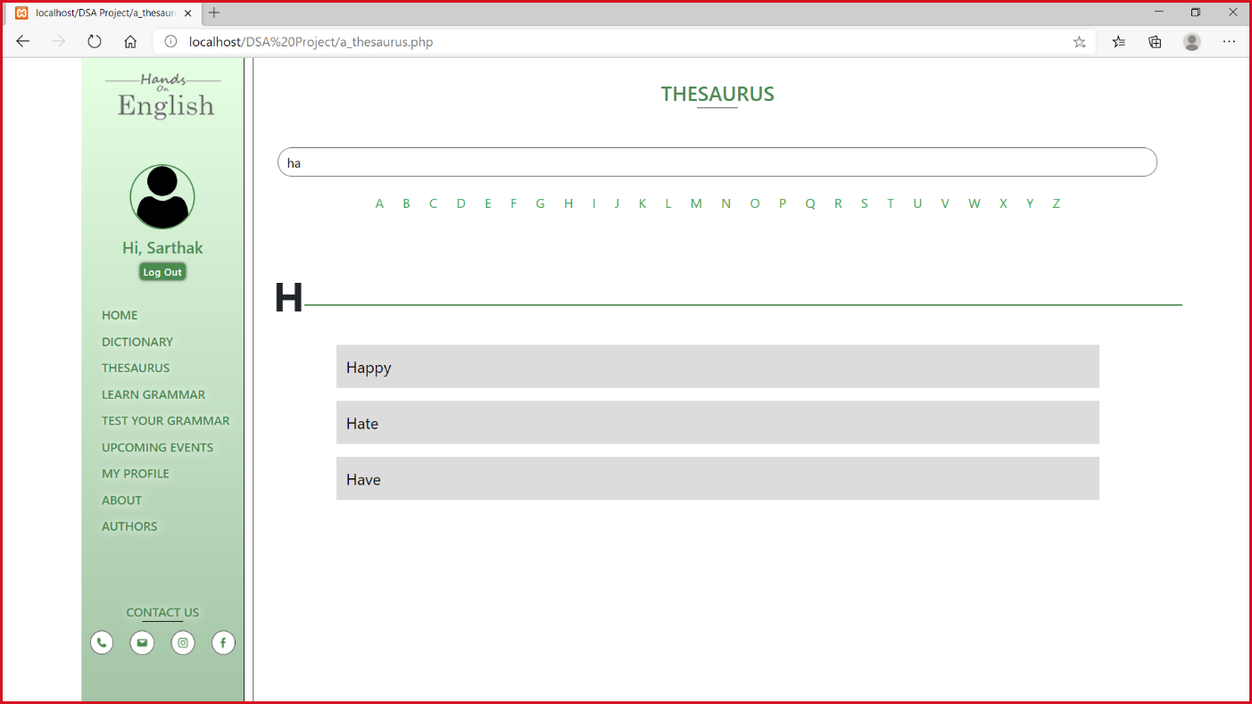

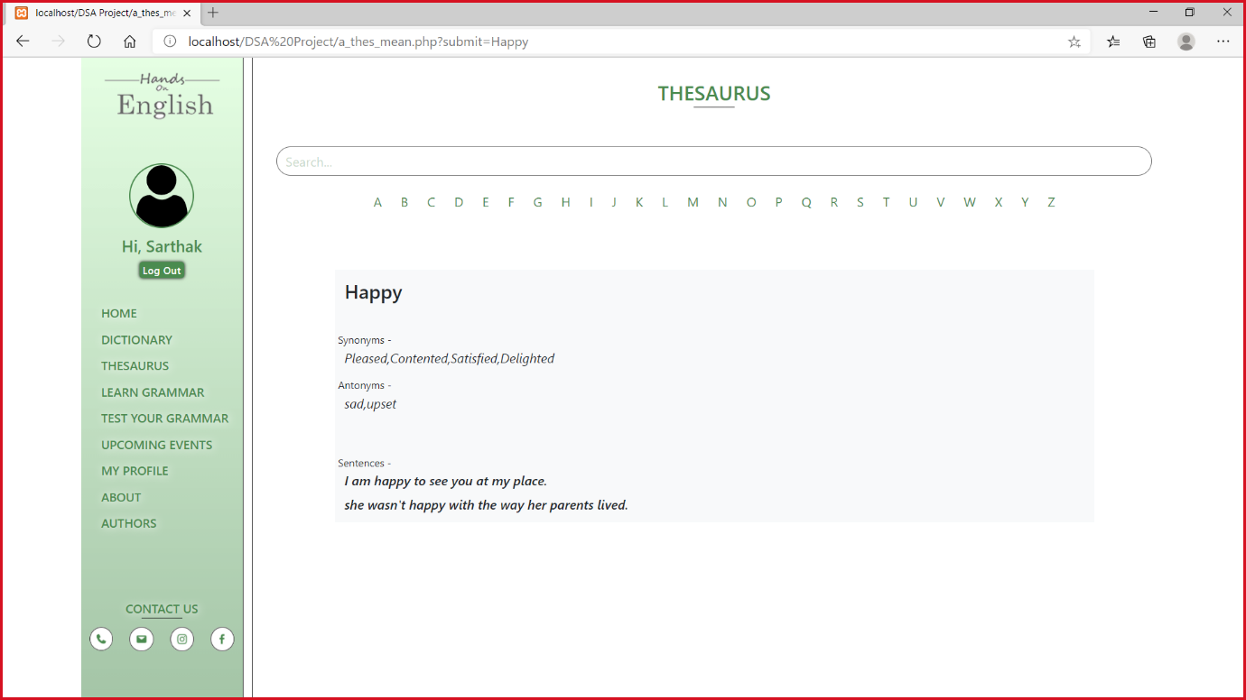

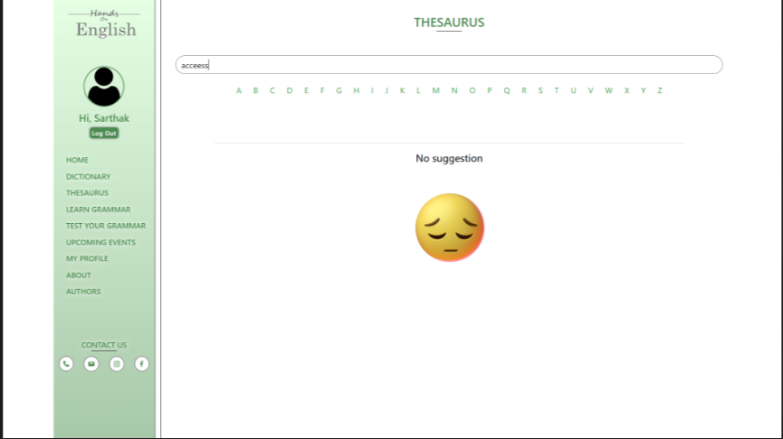

* **TESTS/QUIZZES**

We also arranged a number of test series for the students so that they can check their improvement and can even work smartly on their English improvement.

The questions of the quiz won’t be repetitive which will help students to encounter with new and latest questions every time they attend the quiz.

To calculate scores and ranks of the student who have attended the test, we be used Stack and for assigning questions for tests Circular Queue was used.

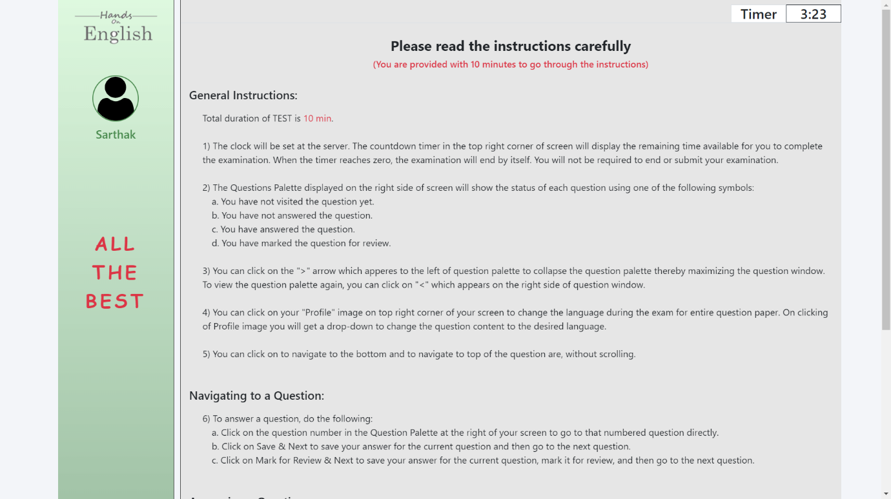

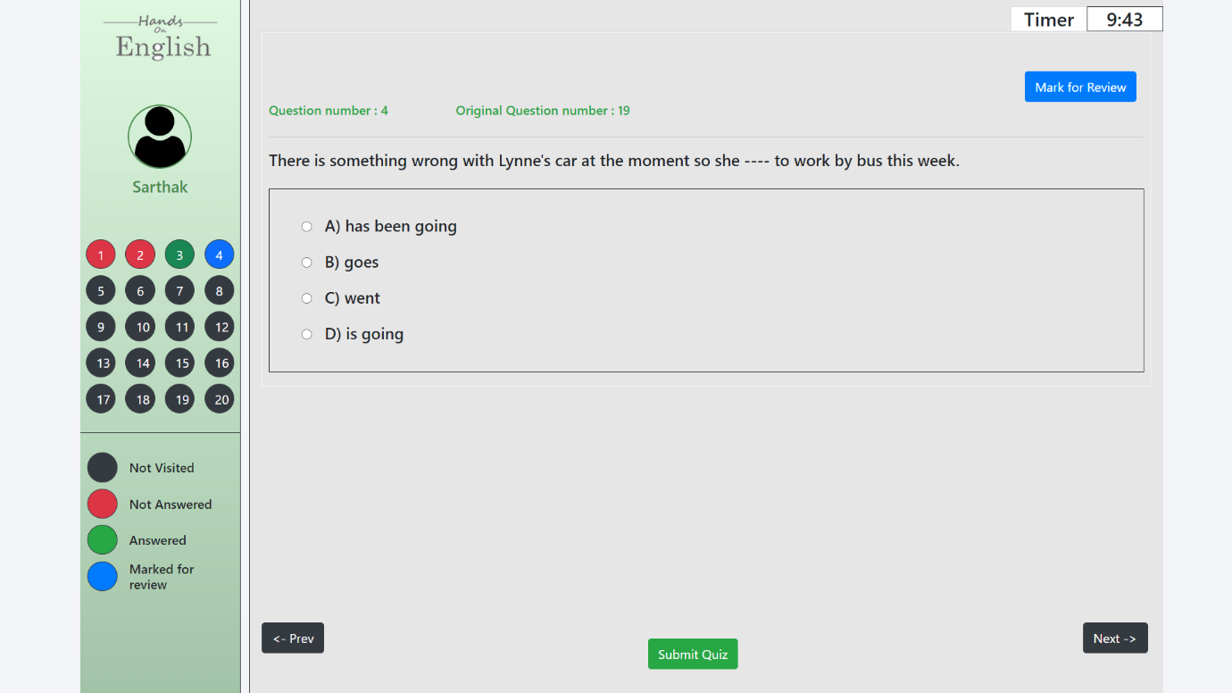

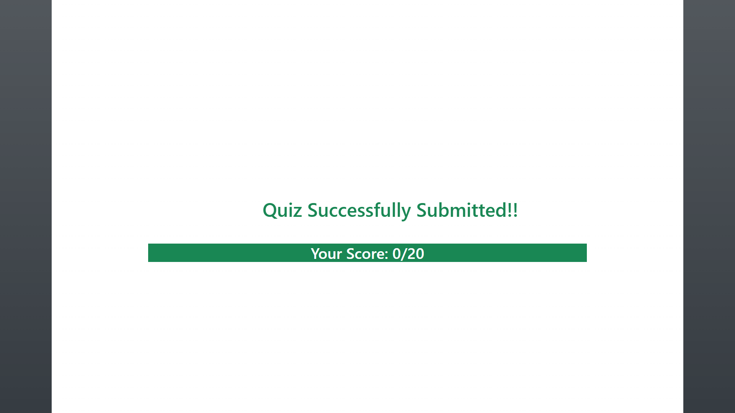

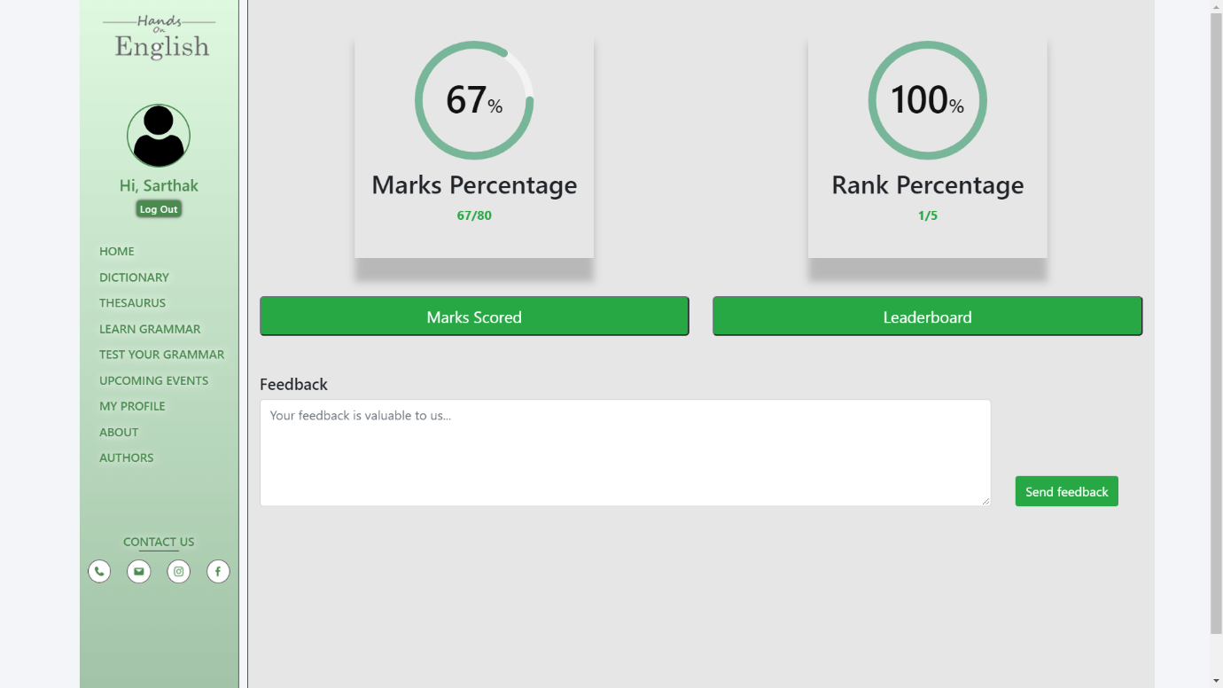

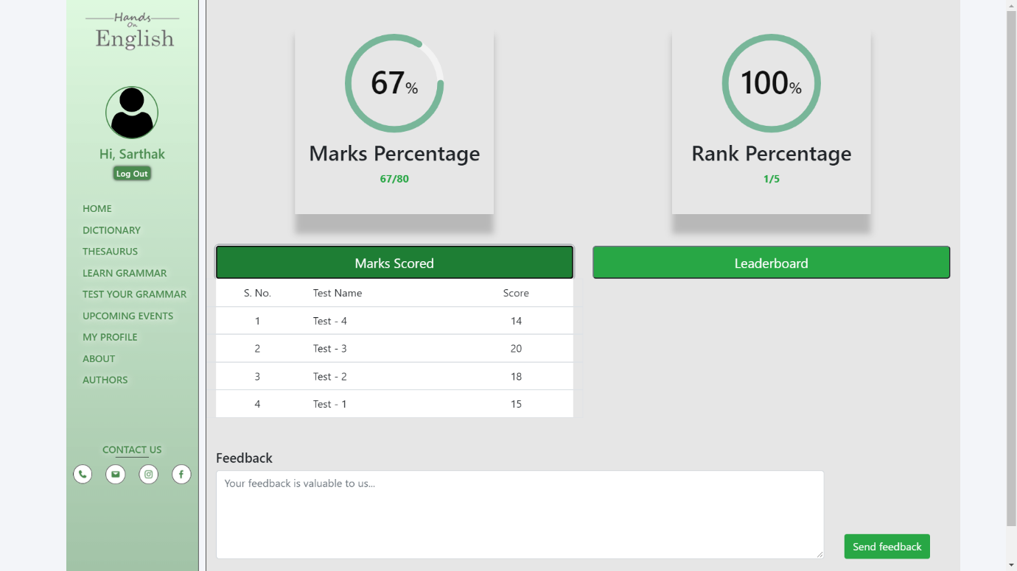

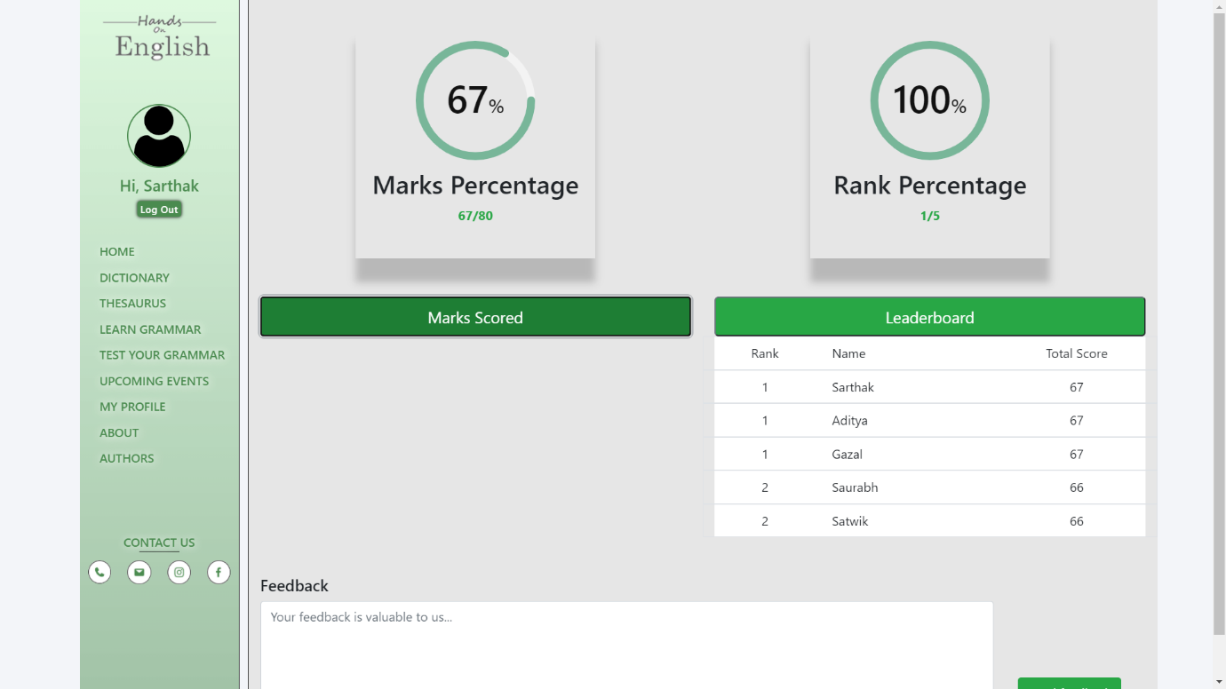

* **EVENTS**

Under this section, we gave latest updates of the upcoming events related to English/Grammar such as Essay-writing, Letter-writing, Content-writing, Story-writing, etc.

Taking part in such events will develop competitive spirit among the students that will help them to learn the subject even more enthusiastically.

Priority Queue will be used under this segment. This will help us in prioritizing the events which are left with very less time to conduct so that students could participate within the time limit of the event.

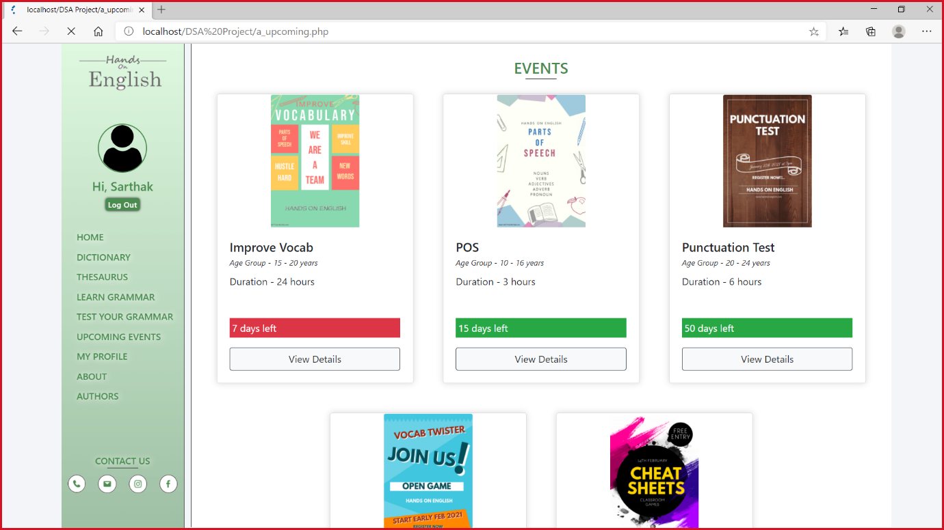

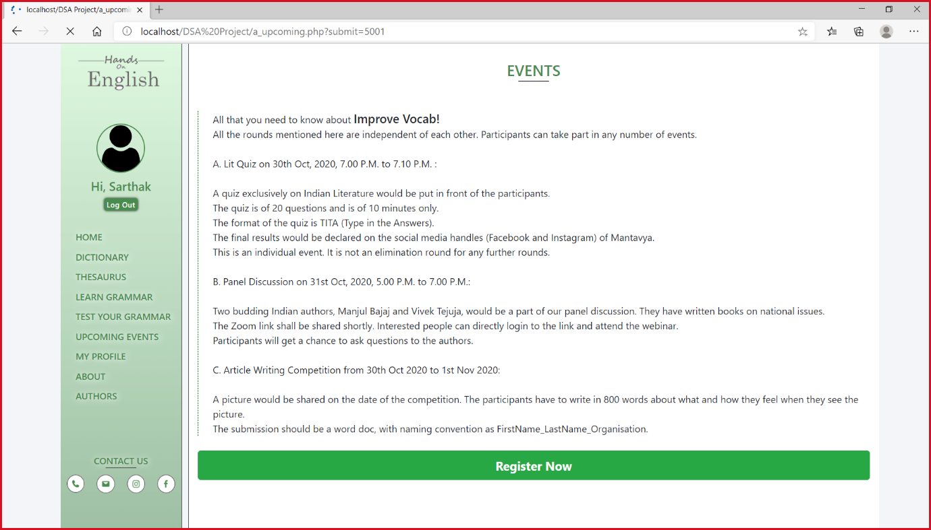

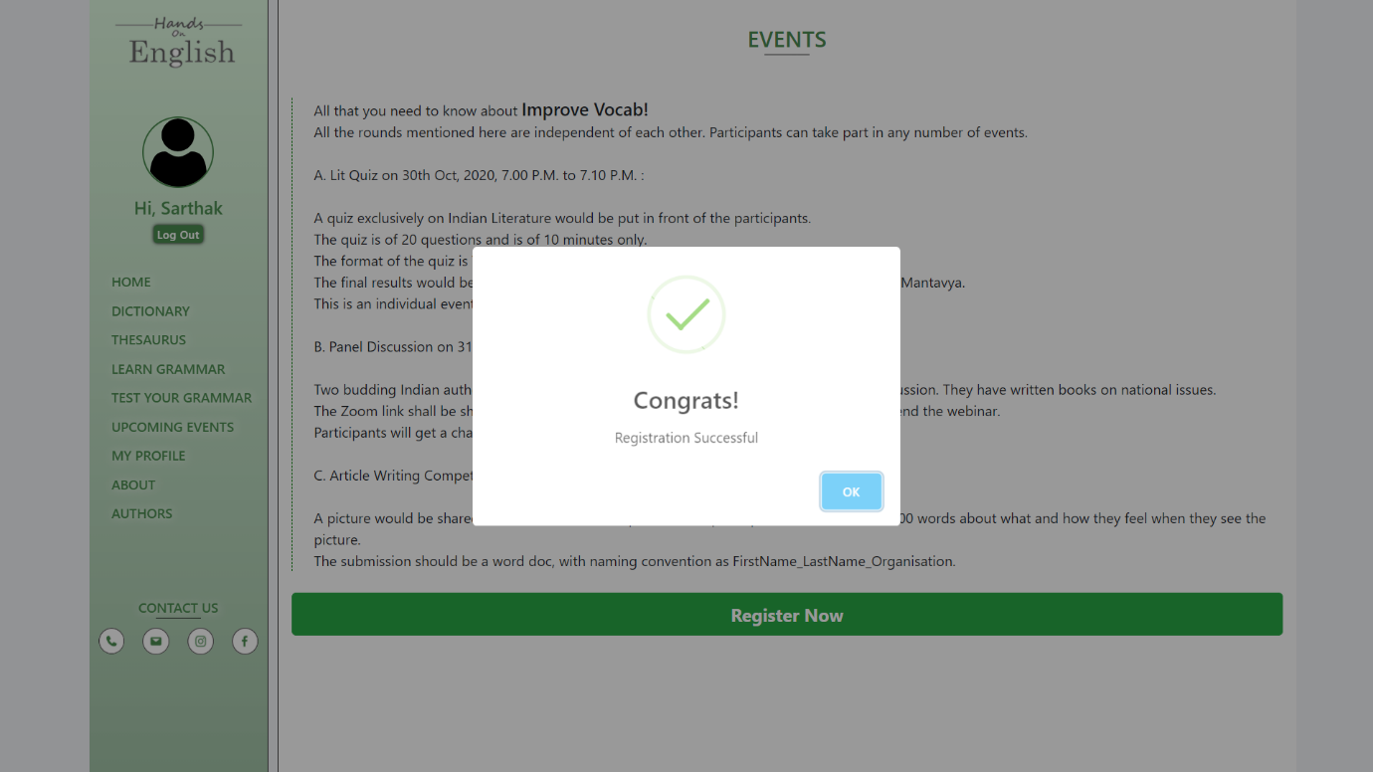

* **LEARN GRAMMAR**

This section will contain grammar related videos to clear up with the concept in which the students have doubt. It will feature some best teaching videos that will again be beneficial for the students who have an urge to learn.

Here the videos will be available depending upon the popularity of the video which depends on star rating and views on the video.

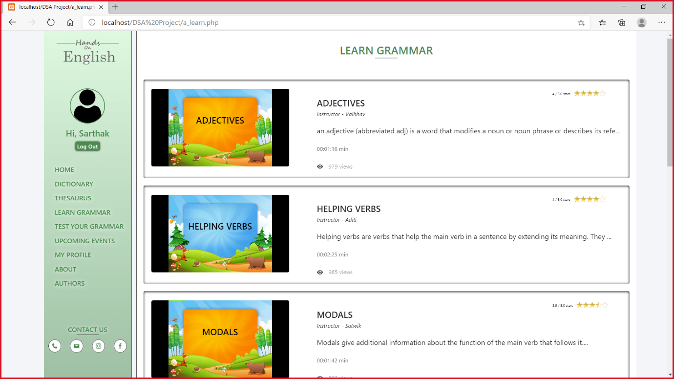

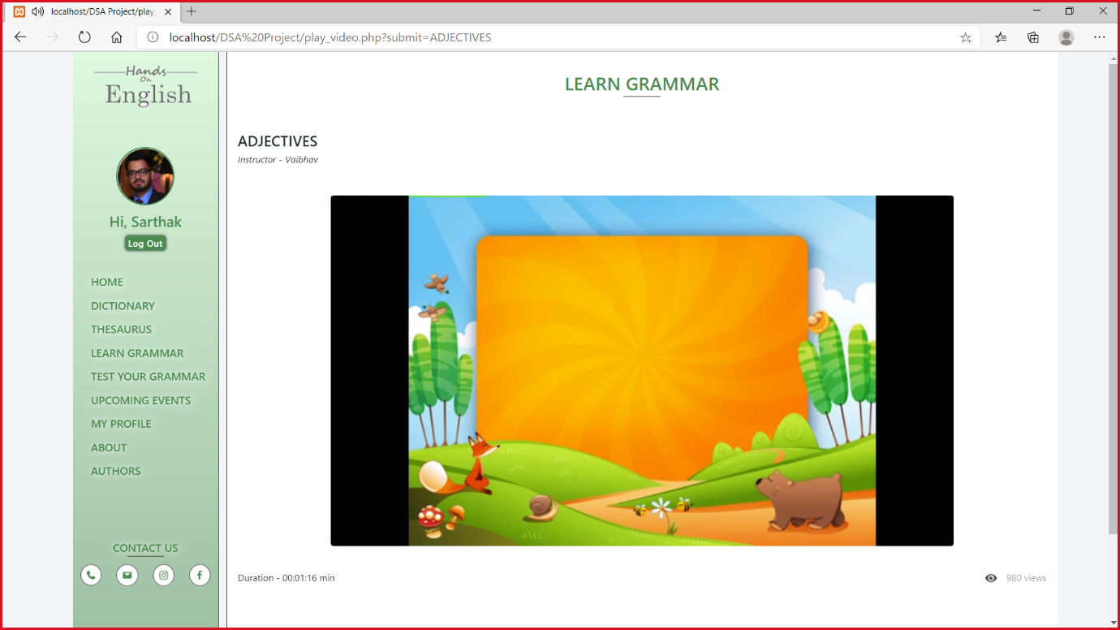

**RESULTS AND DISCUSSION**

“Hand On English” is a professional website in which will help the upcoming generation and students to learn proper grammar and help them to represent in a very decent and professional manner. This will altogether help them to achieve personality development also by being fluent in English. This website contains the following features:

* DICTIONARY
* THESAURUS
* TESTS/QUIZZES
* UPCOMING EVENTS
* LEARN GRAMMAR

Each section consists of different facilities, for example Dictionary contains the facility to search the words and their respective meanings. Thesaurus facilitates user with antonyms, synonyms, etc.

We will also arrange N number of tests for the students so that they can check their improvement and can even work smartly on their English to improve it.

The questions of the quiz won’t be repetitive which will help students to encounter with new and latest questions every time they attend the quiz.

This is not just an ordinary website. We compared many working and well-established sites to make our website the best and superior to all.

We noted the flaws that were there in other websites and tried our best to improve them in our website. This enhances the features of our website even more.

How is the material available in Hands On English?

Hands on English is a site which delivers all the important aspects of learning English. Students log into Hands on English and can view Dictionary, Thesaurus, go through the lectures in the section Learn grammar and can also appear in the test series to keep the track of his improvement along with participating in different events. Once a student is in their course site, they can access lectures given by our experts.

How are online exams graded?

Online exams are graded just like classroom exams in MCQ format. Standard exams include reading the course text and additional materials, active participation in online activities, quizzes or tests, etc. At the end of exam, the result will be displayed along with marks percentage and leader board.

What sort of online activities related to grammar are there in Hands On English?

Online activities can be viewed under the section upcoming events. The events are arranged as per the priority of upcoming date. some examples of the events are: Improve Vocab, Parts of Speech, Punctuation test, Vocab Twister, Cheat sheet and many more….

How can I keep the track of my improvement?

Online exams with repeating question are conducted after the exam one can check his progress through leader board and marks percentage. The student can also visit my profile column to keep a track of his performance.

**CONCLUSION**

English is one of the most spoken languages in the world. The aims of learning language are to develop the listening, speaking, reading and writing (LSRW) for effective communication. English language content made the tune with these focus skills. This content analysis of English shows that the site focuses on many more constructive activities such as encouraging to rearrange the information, thinking, problem solving, group projects, group presentation, dramatization, role play, group discussion interaction and enquiry-based learning, Opportunity to ask questions, analysis of knowledge and self-definitions. In this site tried to inculcate all the necessary and the basic concepts which are required to learn English i.e. Dictionary, thesaurus, grammar videos, online exams as well as fun events to learn grammar with joy. We used many data structures to construct this site: array, stacks, circular queue, priority queue, general tree.

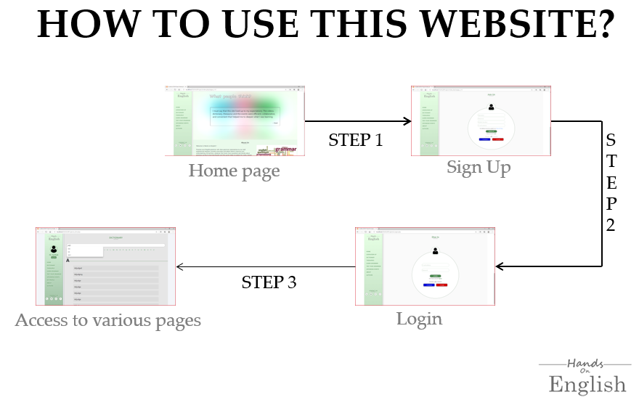

**REFERENCE**

* https://www.grammaring.com/english-grammar-test
* https://learnenglish.britishcouncil.org/online-english-level-test
* https://www.ego4u.com/en/cram-up/tests
* https://www.thinkexam.com/

**APPENDIX**

**(Code Snaps)**

* Dictionary

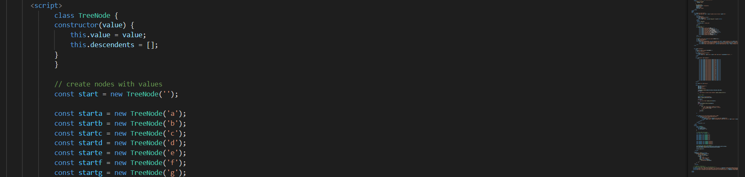

* Thesaurus

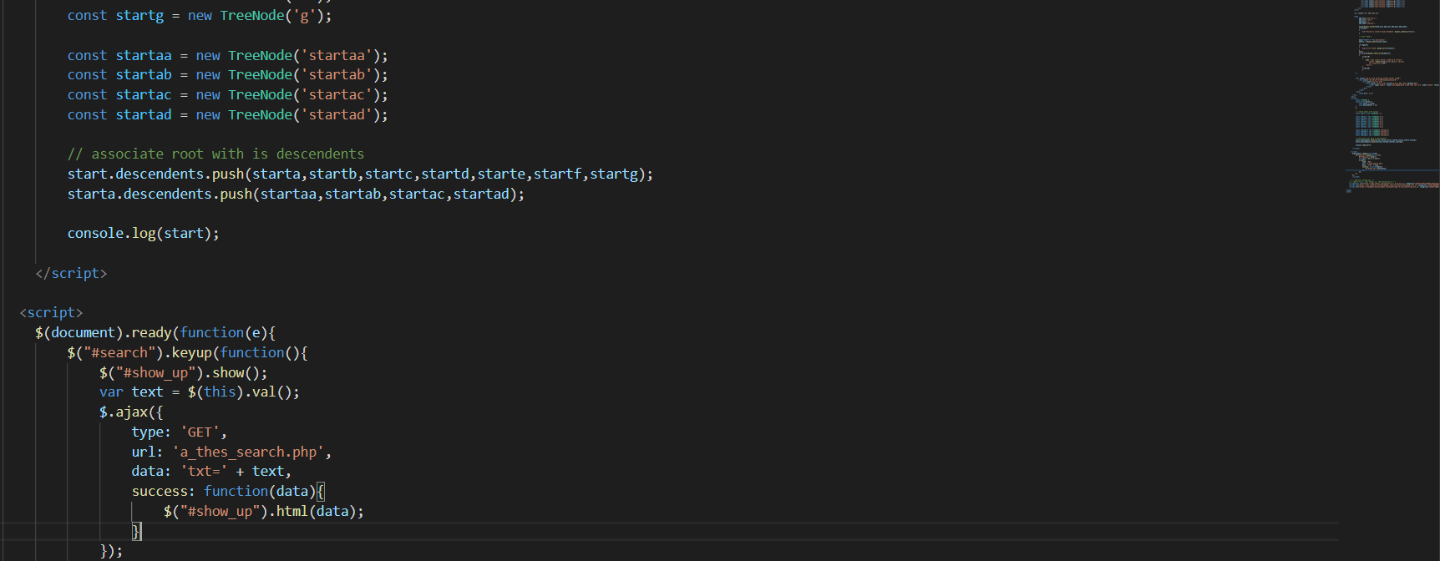

* Tests/quizzes

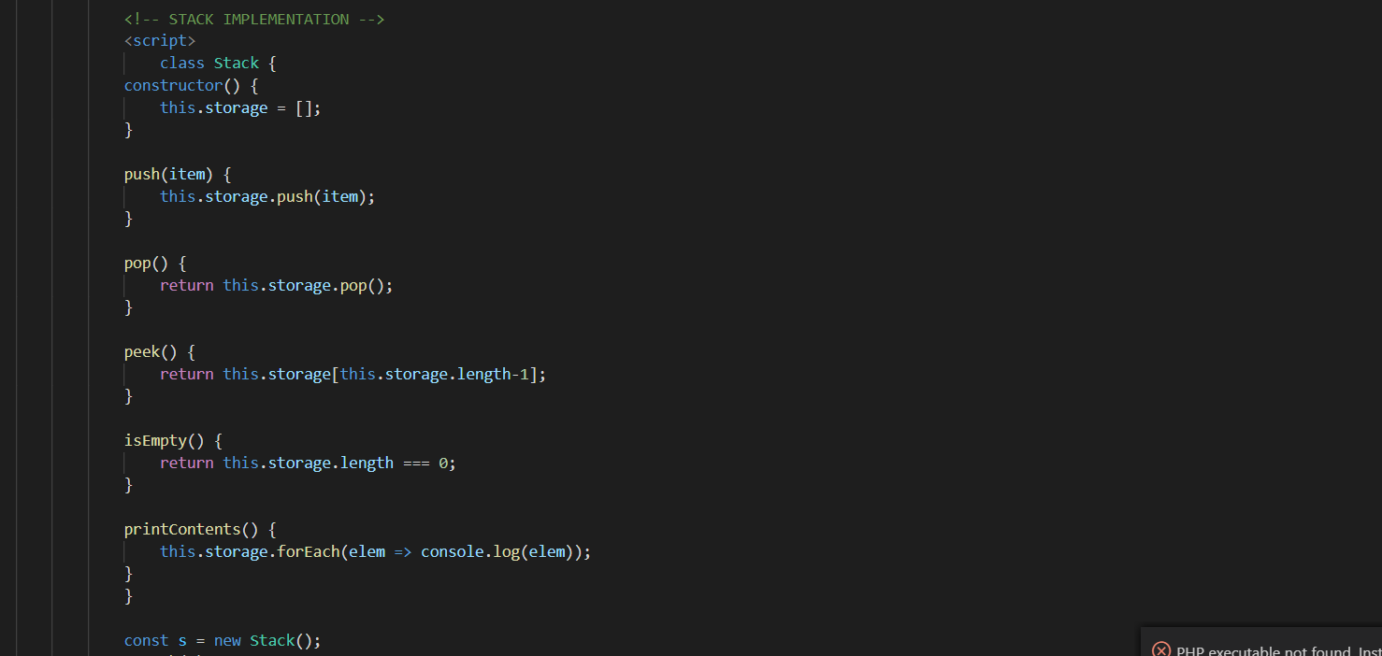

* Upcoming events

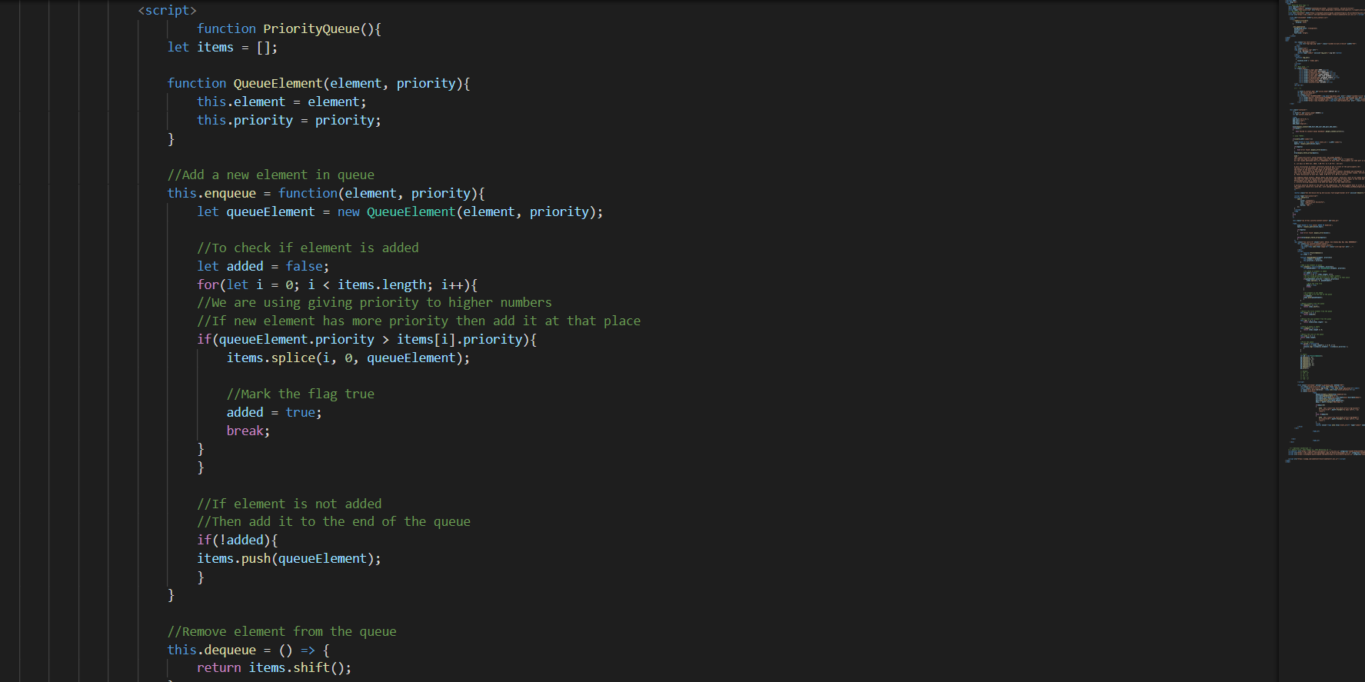

* Learn grammar

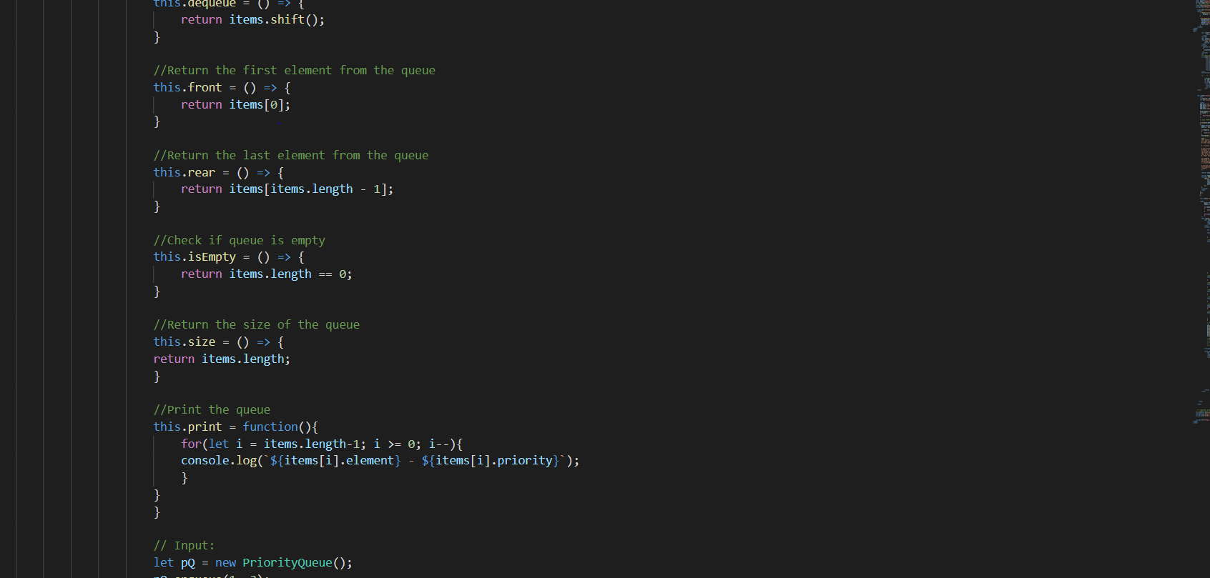

**Video Link –**

https://drive.google.com/drive/folders/1lKbCPX9zt3nL10d1csULqYMVpHVJbBYU?usp=sharing